Students: Andrew-Nicholas Rusu, Patrick Bucioaca
Date: September 21st, 2026
Class: .NET Development
Teacher: Reza Mirsalari
All Reporting of C# Source Control with Git, GitHub, and Visual Studio(Assignment 4)
- The initial Visual Studio project and working application: 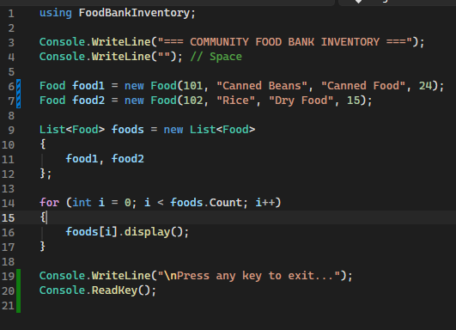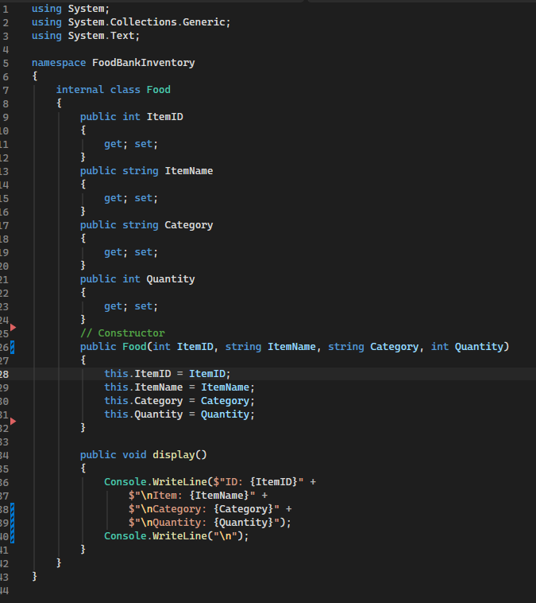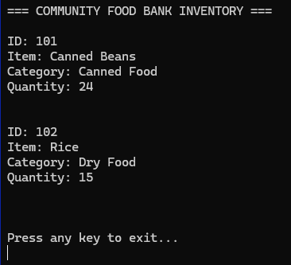
- The project being added to Git/source control:
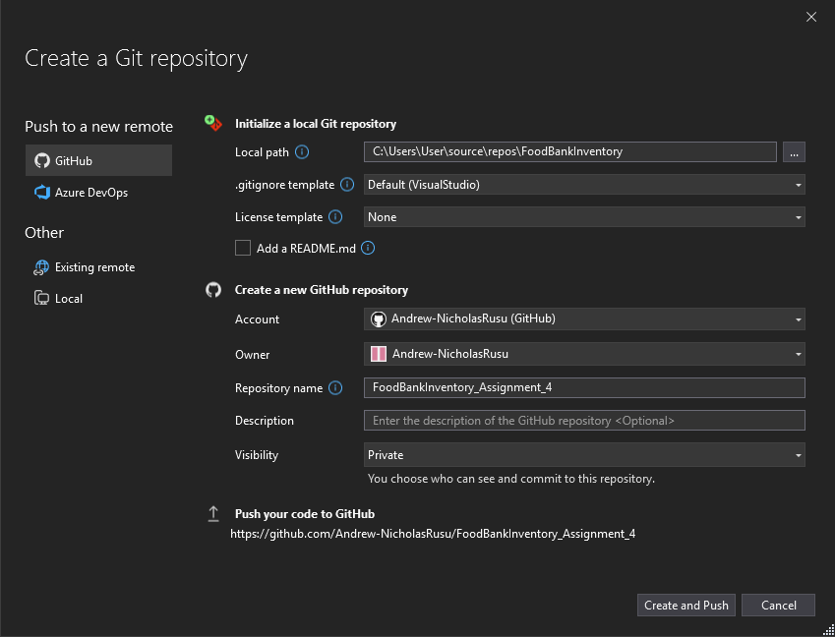
- The GitHub remote repository:
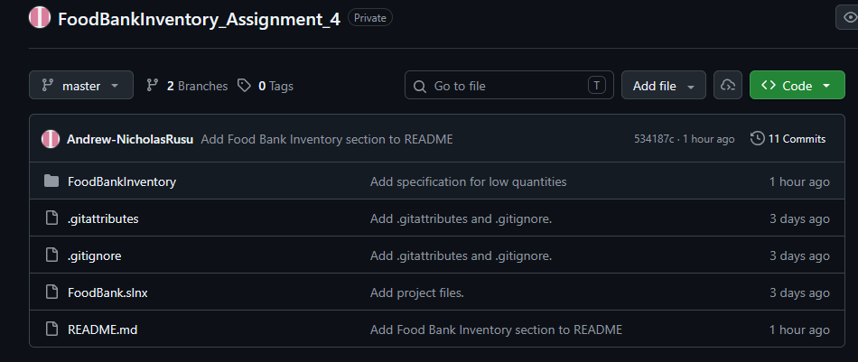
- The initial commit:
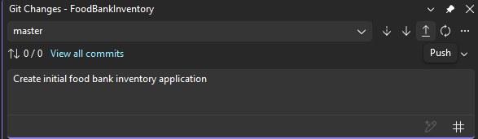
- A modified file appearing in Git Changes:
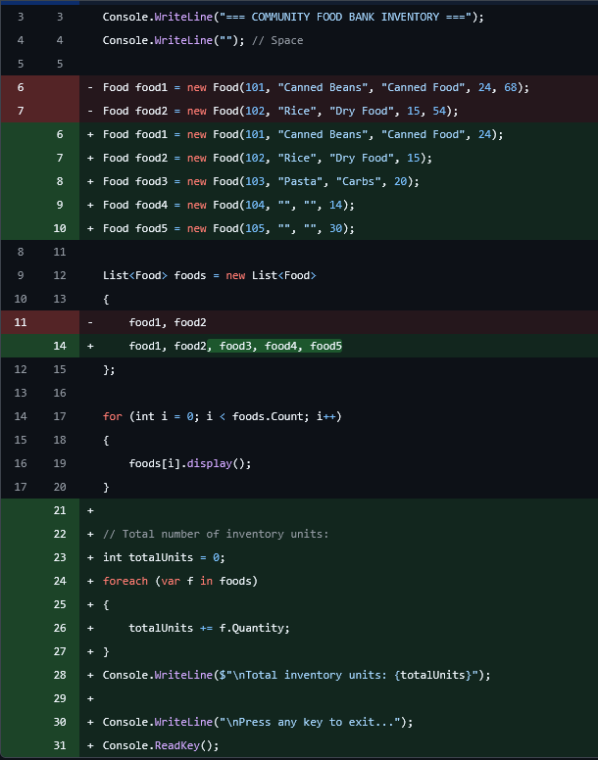

- A meaningful diff:
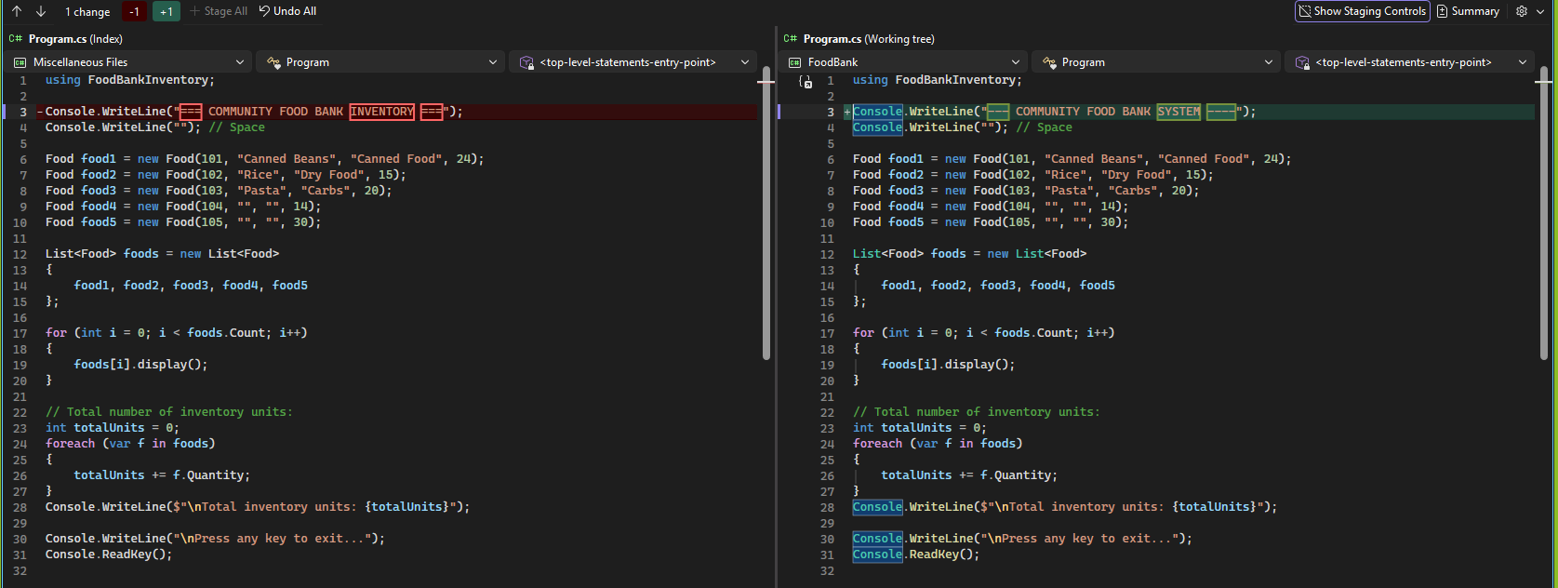
- A meaningful commit message:
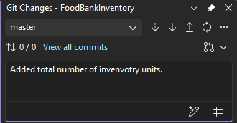
- A successful push to GitHub:


- Repository/commit history:
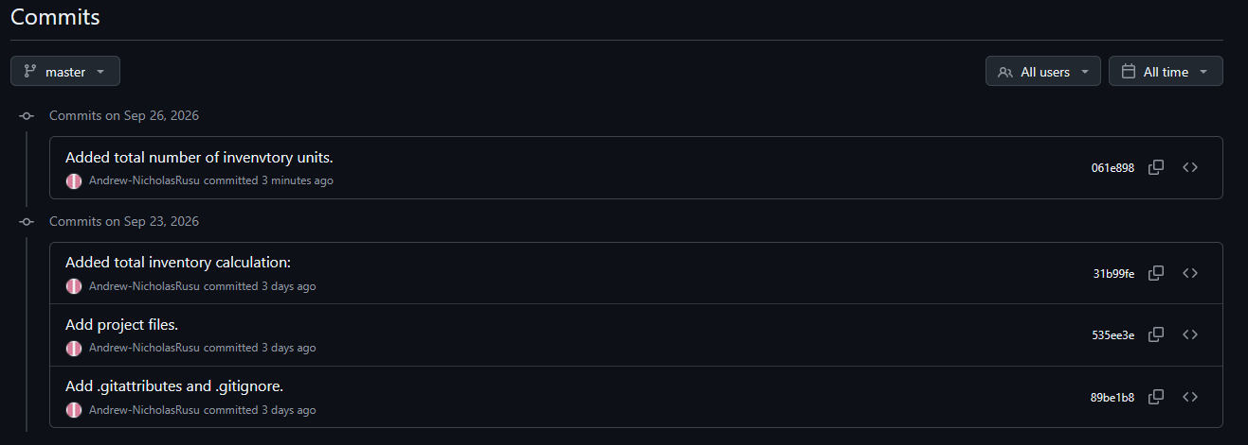
- Creation of the feature branch:
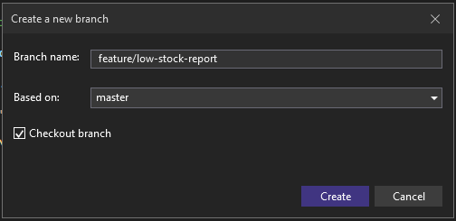
- Development occurring on the feature branch:
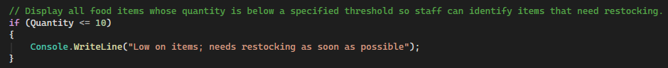

- The feature branch commit:
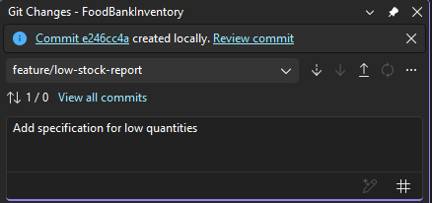
- The merge into main:
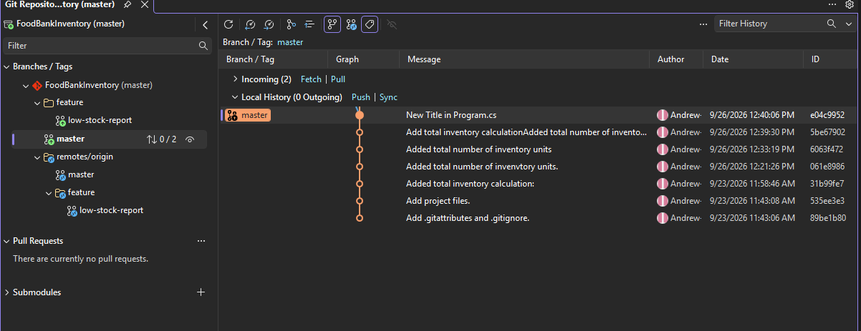
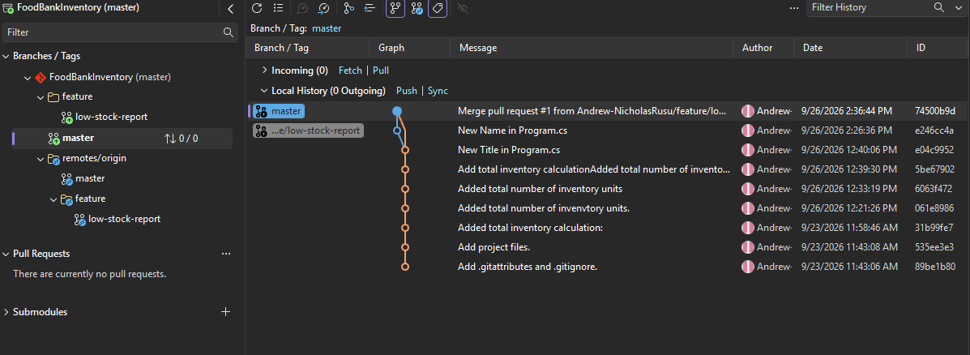

- Successful execution after the merge:
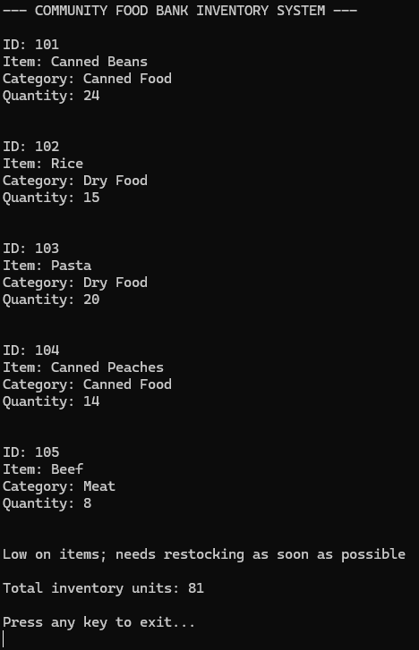

- The temporary unwanted modification:
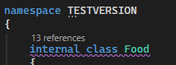
- Restoration/recovery of the intended version:
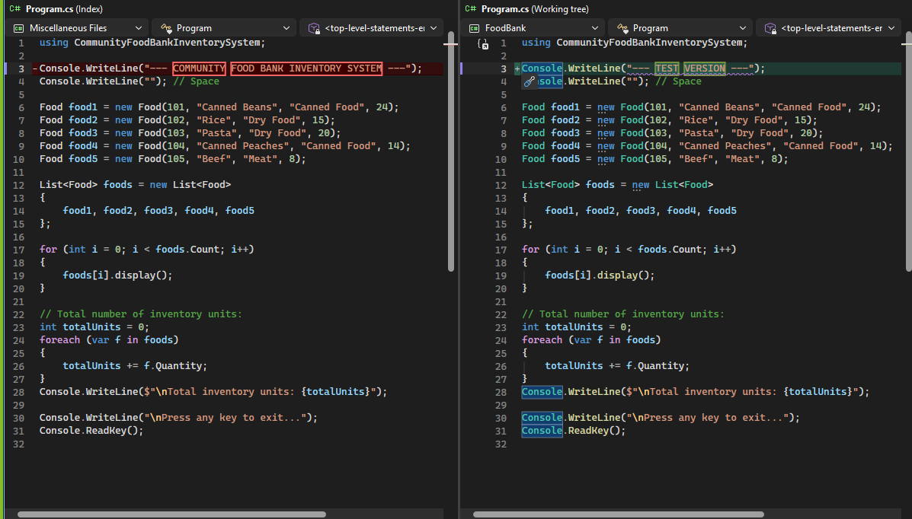
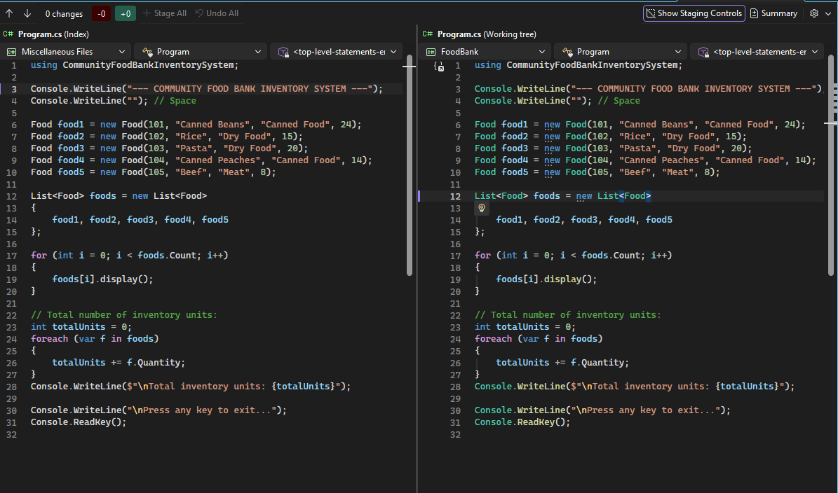
- fetch/pull operations:
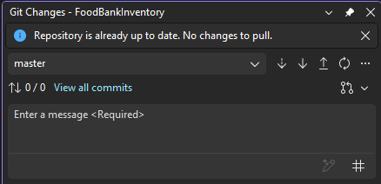
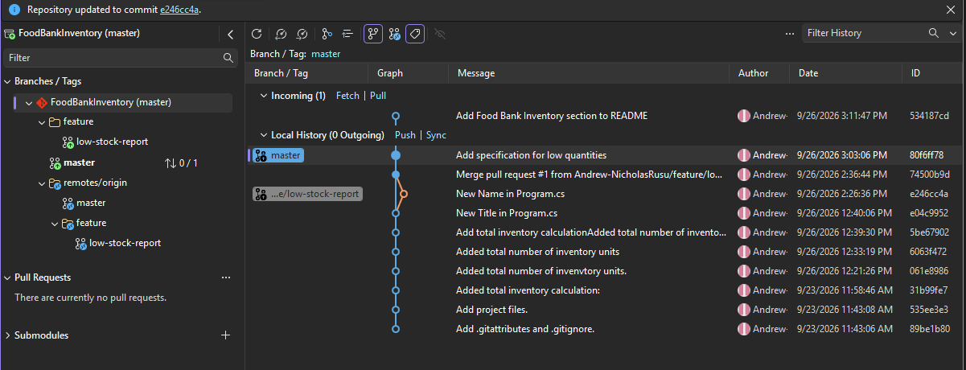
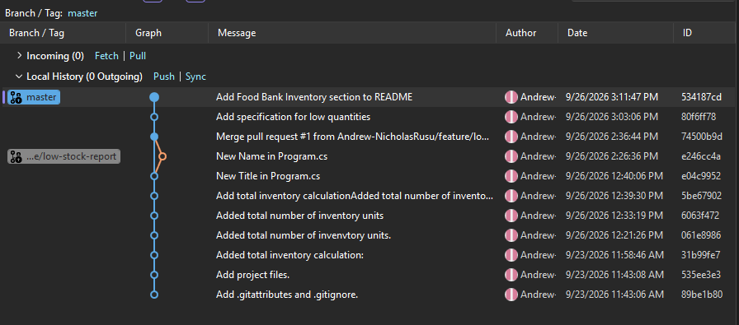

- The final repository on GitHub:
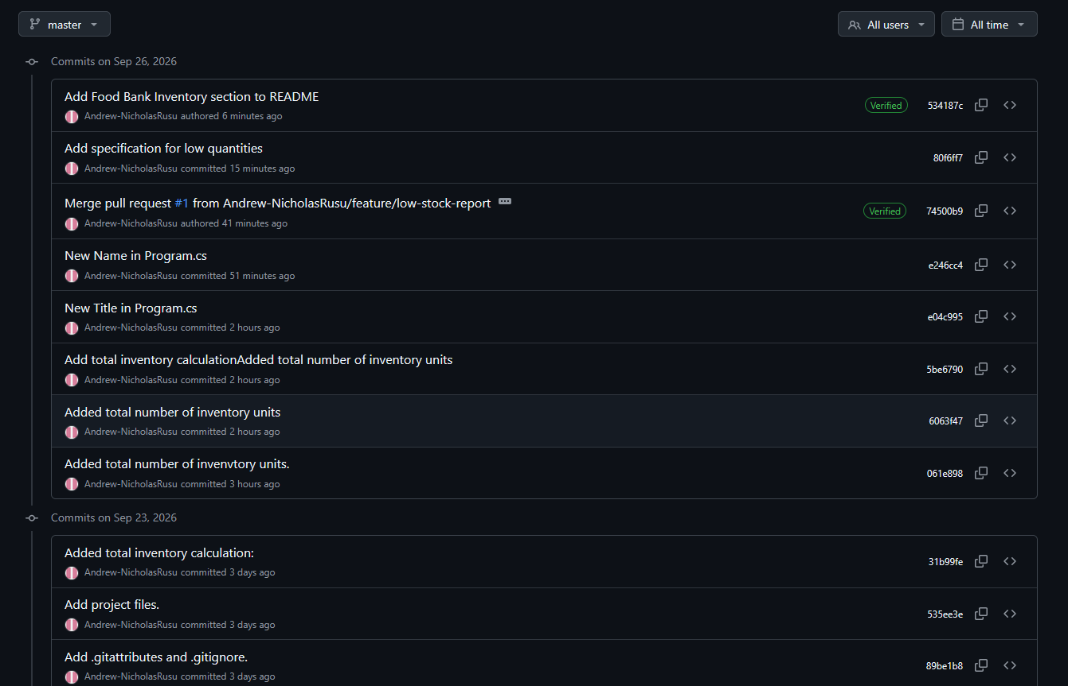
- The final Visual Studio project:
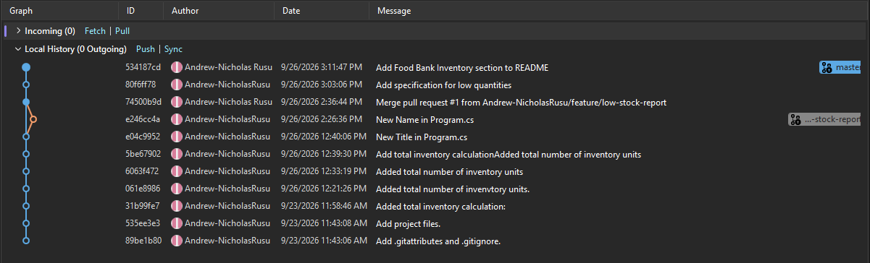

- The final console output demonstrating the required functionality:
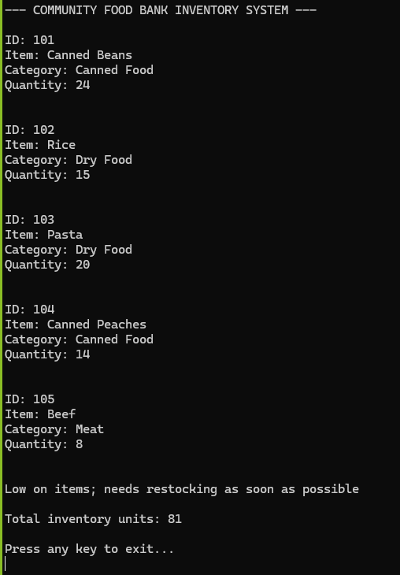

Git Concepts Demonstrated:
- Git and GitHub:
  - Git: records changes to files and allows you to create commits, branches, and versions of your project.
    - Example: Git can record when you change the restocking condition in Food.cs from:
      - if (Quantity <= 10)
    - to:
      - if (Quantity <= 15)
  - GitHub: an online service for storing Git repositories and collaborating with other developers.
    - Example: stored in a repo called: https://github.com/AndrewNicholas/FoodBank
- Working directory and Repository:
  - Working directory: the folder on your computer containing the files you are currently editing.
  - Repository (repo): the project together with Git's history and tracking information.
    - Contains:
      - Your project files
      - Previous commits
      - Branch information
      - Git metadata, usually stored in a hidden .git folder
- local repository and remote repository:
  - Local repository: the Git repository stored on your computer.
    - Example: After downloading the Food Bank project, you can have a copy at: C:\Projects\FoodBank
  - Remote repository: another copy of the repository stored somewhere else, usually on GitHub.
    - Example: origin = https://github.com/your-username/FoodBank.git

- Commit and Push:
  - Commit: saves a set of changes to your local repository
  - Push: uploads your local commits to a remote repository, such as GitHub.
- Fetch and Pull:
  - Fetch: downloads information about new commits, branches, and other changes from the remote repository, but does not modify your working files.
  - Pull: downloads changes from the remote repository and integrates them into your current local branch.
- Branch and Merge:
  - Branch: an independent line of development.
  - Merge: combines changes from one branch into another.
- Clone and Fork:
  - Clone: copies a remote repository from GitHub to your computer.
    - Example: git clone https://github.com/your-username/FoodBank.git
      - Create a local copy of the Food Bank project
  - Fork: a server-side copy of someone else's GitHub repository under your own GitHub account.
    - Example: if the original project belongs to:
      - community-team/FoodBank
    - You can fork it to:
      - Andrew-NicholasRusu/FoodBank
- pull and pull request:
  - Pull: A Git operation that downloads and integrates changes from a remote repository into your local branch
    - Example: if another developer adds a new food item or changes the inventory logic on GitHub, you can pull those changes into your local Food Bank project.
  - Pull Request: A GitHub request asking that changes from one branch or repository be reviewed and merged into another branch.

GenAI Disclosure Statement
- I used AI to make a simple calculation for the total number of inventory units found in the Program.cs program. I used it so I can simply calculate the entire storage of all 5 quantities of food found in the inventory system.
- I also used it to debug my regular code and see if it works properly, which is why you see these last few lines in the Program.cs file:
  - Console.WriteLine("\nPress any key to exit...");
  - Console.ReadKey();

